
Needs Led Approach- Information for Families

We have provided this information because you are wondering whether you or your child is showing signs of neurodevelopmental differences. You might have had a conversation with a health professional or teacher about using a Needs Led Approach to support any needs you or your child has.
We would like to tell you more about the approach and where to find out more information and access support.
The Needs Led Approach has been developed with families, children/ young people and education settings to:
- help understand more about a person’s strengths and needs
- help understand how to help
Who Completes the Approach?
A Needs Led Approach will usually be completed with home and school together. All education settings/ schools are able to access free training and resources to use this approach. If your child is not in an education setting, the Parent Carer forums will be able to support you to use a Needs Led Approach. Please see below for details. GPs do not make direct referrals into HCRG Care Group for suspected neurodevelopmental conditions.
What if my Child Needs a Referral for a Diagnostic Assessment?
We hope that a Needs Led Approach will help to support you/ your child. It will help everyone to understand whether an assessment will meet the needs that have been identified.
How do I find out more?
Support for understanding more about how the profile works is available here:
https://bswcommunityservices.co.uk/self-help-guides/neurodiversity-needs-led-approach/
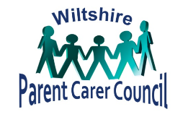
For Wiltshire families who would like to find out more, please email ndi@wiltspcc.co.uk. You can also call Wiltshire Parent Carer Council on 01225 764647 and choose the ND pathway option.
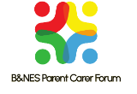
For B&NES families who would like to find out more, please contact the B&NES Parent Carer Forum ND Support Line. The line operates a callback system. Parent carers can call 01761 502515 and leave a message. The email address is support@banespcf.co.uk

