DLD Bubble Toolkit
for Speech, Language and Communication

Child’s Name: Child’s DOB: Date this form was started:

The DLD Bubble Toolkit was developed by The Communication Intervention Team (CommIT), with support from NAPLIC (a national organisation of teachers, speech and language therapists and other professionals). The toolkit provides information, strategies, practical activities and suggested resources that can be used within the classroom to support communication. The full resource can be accessed here:
NAPLIC | DLD bubble toolkit - NAPLIC
The toolkit starts on page 13. Use the DLD Bubble Toolkit to:
- Observe the CYP across all areas of learning and experience.
- Identify areas of strength and need.
- Identify target areas.
- Identify strategies to implement.
- Monitor and review.
Refer to the diagram on the following page.
Complete the plan on pages 3 and 4.
Consider referral to Speech and Language Therapy following your review of the strategies tried.

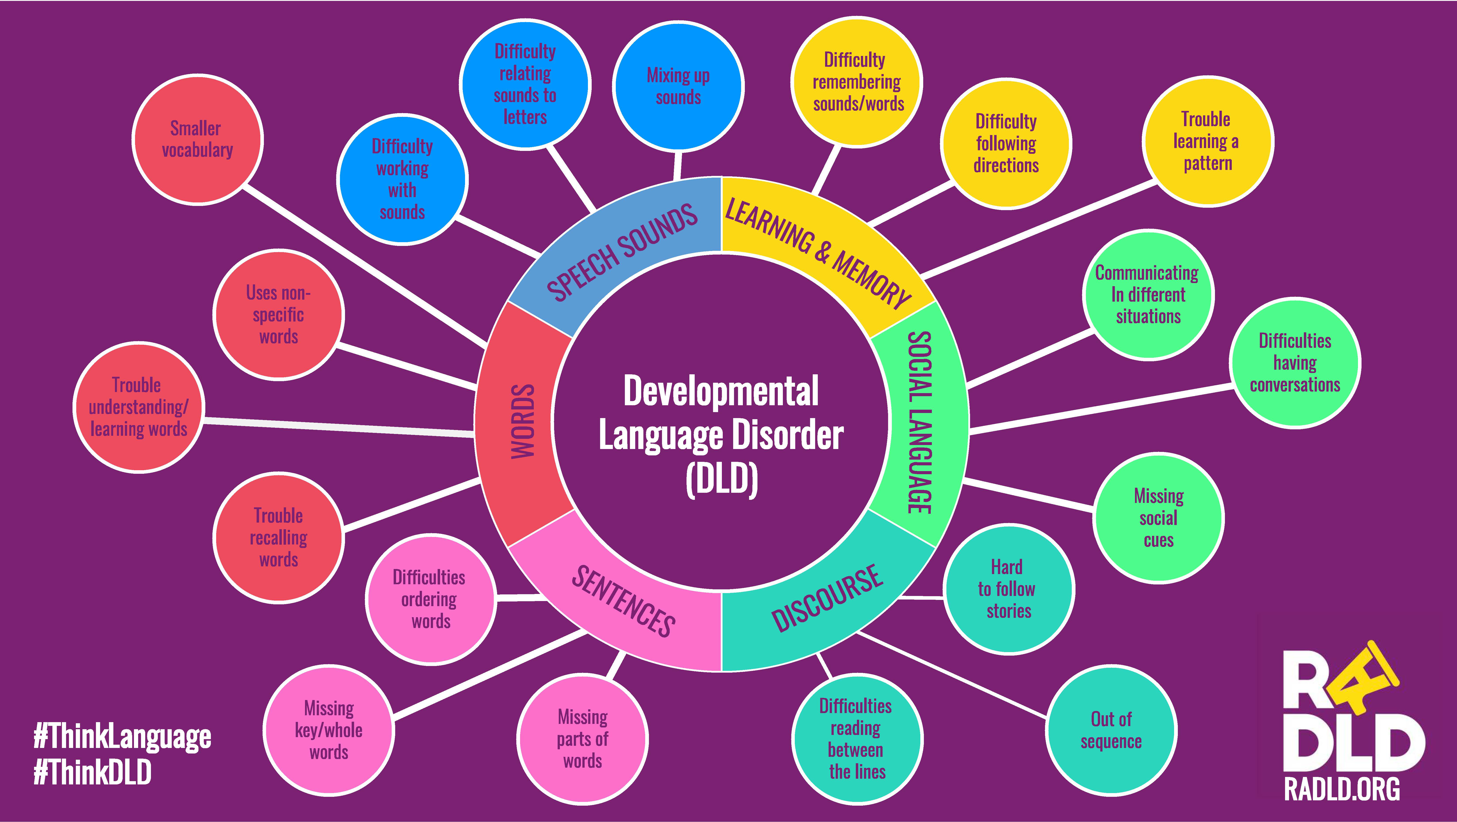

if target | Words | S – Strength  E – Emerging  P – Priority area of need  (OBSERVE & IDENTIFY) | What will be put in place, by Who, How Often? (DO) | After 3 months: What difference has this made? (REVIEW)
 | W1. Smaller Vocabulary
 | W2. Uses non-specific words
 | W3. Trouble understanding/learning words
 | W4. Trouble recalling words
if target | Sentences | S – Strength  E – Emerging  P – Priority area of need  (OBSERVE & IDENTIFY) | What will be put in place, by Who, How Often? (DO) | After 3 months: What difference has this made? (REVIEW)
 | S1. Difficulties ordering words
 | S2. Missing key/whole words
 | S3. Missing parts of words
if target | Discourse | S – Strength  E – Emerging  P – Priority area of need  (OBSERVE & IDENTIFY) | What will be put in place, by Who, How Often? (DO) | After 3 months: What difference has this made? (REVIEW)
 | D1. Difficulties reading between the lines
 | D2. Out of sequence
 | D3. Hard to follow stories
if target | Social Language | S – Strength  E – Emerging  P – Priority area of need  (OBSERVE & IDENTIFY) | What will be put in place, by Who, How Often? (DO) | After 3 months: What difference has this made? (REVIEW)
 | SL1. Missing social cues
 | SL2. Difficulties having conversations
 | SL3. Communicating in different situations
if target | Learning and Memory | S – Strength  E – Emerging  P – Priority area of need  (OBSERVE & IDENTIFY) | What will be put in place, by Who, How Often? (DO) | After 3 months: What difference has this made? (REVIEW)
 | L&M1. Trouble learning a pattern
 | L&M2. Difficulty following directions
 | L&M3. Difficulty remembering sounds/words
if target | Speech Sounds | S – Strength  E – Emerging  P – Priority area of need  (OBSERVE & IDENTIFY) | What will be put in place, by Who, How Often? (DO) | After 3 months: What difference has this made? (REVIEW)
 | SS1. Mixing up sounds
 | SS2. Difficulty relating sounds to letters
 | SS3. Difficulty working with sounds

