B&NES and Wiltshire
Needs Led Approach
Manual

Based on the Portsmouth Neurodiversity Profiling Tool
(researched, revised and evaluated in coproduction with clinicians, care givers and service users in Portsmouth, adapted for use in B&NES and Wiltshire in 2024)

Table of Contents

Topic | Page
Introduction | 3
Context & Aims | 4
Section1: Before You Start | 5
What is Neurodevelopmental (ND)? | 5
The Importance of Understanding Needs | 6
Who is this Approach for? | 6
Masking | 9
Section 2: Understanding and Identifying Needs | 11
How to Use the Needs Led Approach kit | 11
The Needs Led Approach Levels | 13
The Observation Tables | 14
The Nine Neurodevelopmental Areas | 14
- Speech & language Skills | 14
- Energy Levels | 14
- Listening, Attention and Impulse Control | 15
- Emotional Regulation | 16
- Motor Skills | 16
- Sensory Processing | 17
- Flexibility & Adaptability | 17
- Social Interaction & Social Relationships | 18
- Cognitive Skills | 18
Creating a Needs Led Profile | 19
Section 3: Using the Profile to Identify and Plan Support | 21
Level 1 – Creating and Reviewing an Action Plan | 22
Level 2 – Reviewing & Adapting the Action Plan | 23
Level 3- Seeking Advice from the ND Pathway where needs are not being met and having a significant impact | 25
Section 4: Essential Information | 26
Frequently Asked Questions | 26
Contact Details | 29

Introduction
The B&NES, Swindon and Wiltshire (BSW) Integrated Care Board (ICB) is supporting B&NES and Wiltshire Community Children’s Services (provided by HCRG Care Group) to implement a Needs Led Approach where there are concerns about a child’s development to help understand strengths and needs in the context of possible neurodivergence.
The Needs Led Approach is a holistic approach to supporting families in a creative and empowered way. We want to work in partnership between education, health and families to improve outcomes and experiences for children and young people who may be neurodivergent.




A Needs Led Approach is now a requirement of requesting a diagnostic assessment for autism or Attention Deficit Hyperactivity Disorder (ADHD).
This manual is for anyone who may be collaborating to create a Needs Led Profile and Action Plan for a child or young person, to help describe the approach and how to use it. The Manual should be read in conjunction with the Needs Led Approach Training webinar which is available here:

B&NES
bathneshealthandcare.nhs.uk/neurodevelopmental-pathway/


Wiltshire:
wiltshirechildrensservices.co.uk/neurodevelopmental-pathway/

Context
The Needs Led Approach was devised in Portsmouth and is now widely used across the country. We have been trialling this approach in B&NES and Wiltshire with a number of settings since March 2024. We have adapted the approach in response to feedback from settings, other professionals and parent-carers.
Aims
The approach places the needs of children and young people at the centre. It ensures that children and young people and their families can access support and information from the right places, whether or not they have a formal diagnosis of autism or ADHD. The approach also helps to support the needs of those around a child or young person, in understanding more about how to help them meet their potential.

Section 1: Before You Start

What people have told us:

‘[The Needs Led Profile] has enabled teachers to pinpoint additional needs when they can’t quite put their finger on what is going on’
SENCo feedback from the pilot project- May 2024
‘We have really felt like we have been listened to and heard! Nothing was too much and no question was unanswered. I am grateful that [child] was brought onboard to the meetings’
Parent feedback from the pilot project- October 2024
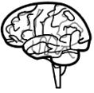
What is Neurodevelopment (ND)?
Neurodevelopment is the effect of brain ‘wiring’ on development. We are considering the effect in these nine areas of development:
1. | Speech and Language | 
2. | Energy Levels | 
3. | Attention and Impulse Control | 
4. | Emotional Regulation | 
5. | Motor Skills | 
6. | Sensory Processing | 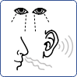
7. | Flexibility and Adaptability | 
8. | Social interaction and Social Relationships | 
9. | Cognition | 

Neurodevelopmental differences are likely to have been present from birth, perhaps only having an impact when life becomes more demanding. These differences are not learnt behaviours, but part of a child/young person’s nature. Sometimes, if these differences are significantly divergent from typical development, they may indicate ‘neurodivergence’.
The Importance of Understanding Needs
If we are able to understand the type and impact of any differences in these nine areas, we will be able to better understand and support a child or young person. The child and young person will also be able to better understand themselves. Working within this framework allows support and understanding for identified needs to be offered regardless of diagnosis. The focus is on understanding a child/young person’s strengths and needs, rather than focusing on whether a threshold for a diagnosis can be met.
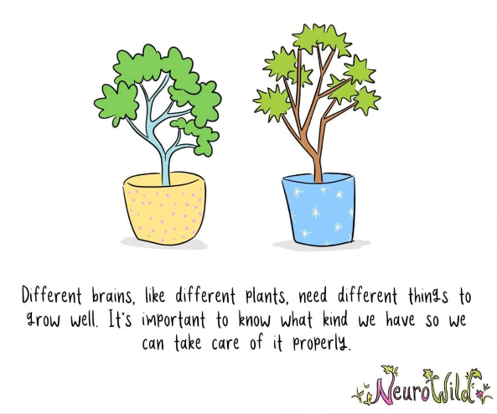
Using this approach might be sufficient in itself to identify and provide suitable support or further assessment may be required to meet needs.
Who is this Approach for?
It is not necessary or appropriate to use a Needs Led Approach for every child or young person. The profile should only be used where possible neurodevelopmental

differences/ neurodivergence has been identified. These could have been identified by a child or young person, family member or someone else who may be working with the child or young person.
Even if some neurodevelopmental differences or neurodivergence has been identified, it might not be the right time to complete a Needs Led Approach with a family.

Consider:
  - Is it a good time to be working with the family in this way?
  - Are there concerns about the child’s sleep or nutrition?
  - Is there already support being offered to the family or child from other services? How can this be pulled together?
  - Is it the right time to be considering neurodivergence or do other pieces of work need to be completed first?
  - What does the child think about finding out more about their profile? Are they happy for others to be working together to think about what may be helpful for them?
  - Who is the right person to be leading on creating and reviewing the profile and action plan? Do they need to access this training? Or join a drop in with the ND Pathway team to update their knowledge and skills?
Sleep: If there are concerns about sleep, it might not be the right time to complete a Needs Led Approach. Reduced sleep quality and/or quantity can lead to a range of needs and impact, so it is important to consider suitable support and strategies first. Improved sleep is likely to improve other areas of development. Consider using the sleep advice below before completing the Needs Led Profile.
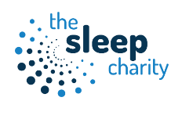
- The Sleep Charity - https://thesleepcharity.org.uk
- Teen Sleep Hub https://teensleephub.org.uk

Factors which help improve sleep quality are;
- Increasing light brightness during the day (i.e., exposure to natural light helps sleep) (Campbell, Dawson, & Anderson, 1993; Sanassi, 2014)
- Decreasing blue light exposure during the night-time, which can be mainly found on smartphones and TVs (Higuchi et al., 2005)
- Keeping a routine when the child/young person wakes up and goes to sleep, will help regulate their sleep cycle, this includes the weekends (Van Dongen, & Dinges, 2003; Giannotti et al., 2002)
- Keeping the room temperature in the 19-24°C range which is optimal for sleeping. This does vary from person to person, but trial and error is the best way to find a person’s optimum sleeping environment (Caddick et al., 2018)
- Not eating too late in the evening (Vander Wal, 2012)
Nutrition: Poor nutrition can lead to a range of needs and impact, so it is important to find out whether a child/young person is having the right nutrition. With suitable support and strategies to improve nutrition, needs and impact may be reduced.
From our own experiences this makes sense. Think about a time when you haven’t eaten for hours, and you experience stomach pains and exhaustion. It’s reasonable to think that if this was an ongoing issue, other people might think that you could be emotionally unregulated, have low energy levels, low attention and low cognitive abilities. Consider using the nutritional advice below before completing the Needs Led Profile.
- Eat Well - https://www.nhs.uk/live-well/eat-well/
Factors to consider:
- How much is the child drinking?
- Is there a drastic change in behaviour after a meal?
- Do they often seem very hungry?
- Over the past few months have you noticed any significant weight gain or weight loss?
- What are they eating for breakfast, lunch and dinner? Is it a suitable mix of the food groups?

Differences in Behaviour in Different Places
If you have considered the above questions and support, and some differences have been recognised in a child’s development, you can use the Needs Led Approach to help you understand more about their strengths and needs. You can use this approach, even if there are differences in behaviour and needs between home and school. It is important that everyone’s views are listened to and respected, even if they don’t match what you may think.
Behaving differently in different settings is not unusual and there can be many reasons for this:
- Being aware of social expectations/social norms
- Feeling comfortable and safe
- Understanding what is happening and what may happen next
- Having a level of control and choice in the setting
- Having needs met
- Not wanting to worry people
- Not wanting to stand out

Masking
The reason that masking is mentioned in this manual is due to the research indicating that long term masking can cause exhaustion, anxiety and depression, especially in females. (Hull et al, 2019; Schuck, Flores, & Fung, 2019; Tierney, Burns, & Kilbey, 2016).
Masking or camouflaging are terms we frequently hear when talking to parents and settings when children are showing different behaviour in different places.
It is important to consider what masking is and how masking is different to children/young people who present differently in different environments but are not masking.
Everyone ‘masks’ sometimes, particularly when faced with a situation we feel anxious about. We might choose to wear certain clothes or rehearse what we are going to say to people to feel more comfortable about fitting in. We might also adapt our behaviour based on social expectations. We would behave differently in an interview to a social event with family. It is also important to remember that children/young people can behave differently in different environments. This by itself, does not mean they are masking.
Neurodivergent masking is when someone has recognised that they are different to those around them and they ‘camouflage’ by copying those around them to blend in.
This could be learning to use eye contact even though this feels uncomfortable. It could be going to a party they would rather avoid because this is what their peers expect. Neurodivergent masking in school could include positioning themselves on the periphery of a friendship group or choosing to wear certain clothes so they do not stand out even if these are uncomfortable.
- Can all children mask?
Children and young people who have developed a level of executive function and level of meta-awareness, so they can identify the differences between themselves, and peers may engage in masking. This level of skill develops from around the age of seven years old.
- If children have not yet developed executive function or meta-awareness why are there differences in their behaviour?
It is important to remember that all people are likely to behave differently in different situations. This is because boundaries and expectations are different across environments. Children and young people frequently behave differently behave differently at home and school. This does not mean they are masking.
The only authentic way to find out whether someone is masking is to ask someone. We cannot assume someone is using masking by looking at observable behaviours.
- Do we want neurodivergent children/ young people to mask?
Masking can be a helpful strategy to enable children and young people who want to fit in, in a social situation. However, it can be exhausting and cause anxiety.
It is important that homes and settings are neuroaffirmative (i.e. accepting of neurodivergent differences) and that the child/ young person does not feel pressure to mask just to fit in.
- What can we do to support children who present differently in different environments?
The focus should continue to be on the child’s individual needs in a neuroaffirmative way.

Section 2: Understanding and Identifying Needs
What people have told us:
[the Needs Led Profile] opened my eyes to so many areas ….that were actually possibly neurodivergent traits; things I had never even realised and things I had never understood that were now making sense’
Parent carer feedback from the pilot project- October 2024
‘This helps us understand how we can meet need and changes the way we think’
SENCo feedback from the pilot project- July 2024

How to use the Needs Led Approach Kit
If you have considered the information in Section 1, and some differences have been recognised in a child’s development, you can use the Needs Led Approach to help you understand more about their strengths and needs.
Arrange a time to discuss the Needs Led Approach with the family, and give them a copy of the ‘Information for Families’ letter to help them find out more before going ahead.
This is not a diagnostic tool to identify diagnosable conditions like ADHD and autism. The Needs Led Approach’s main function is to help identify observable behaviours and appropriate support for a child/young person and those around them.
School and home (including the young person if appropriate) work together to:
- Initial discussion - give the ‘Information for Families’ sheet
- Complete the Observation Tables (these are descriptions of the child’s development)
- Complete the Needs Led Profile using the information from the Observation Tables
- Complete the Action Plan(s)

Parent/carers and schools have told us that completing the Needs Led Profile together at a meeting is beneficial. This helps everyone to understand the child/young person’s strengths and needs in different settings. It also helps to identify steps to take for home and school and the child/young person if appropriate. It can be helpful for schools and parents to prepare for this by reading through this manual and the Observation Tables before the meeting. Parent/carers and schools should consider how to involve the child/ young person in a way that they can share their views and experiences.
All the information and documents you will need are on our website (see contact section). If you need any help, please contact nd.pathway@hcrgcaregroup.com so we can send you a link to one of our drop-in sessions on Microsoft Teams. If you are a parent/carer who needs some help, please see the ‘Information for Families Letter’ where you can find the contact details of the parent carer support.
You will need:
- Information for Families Letter | 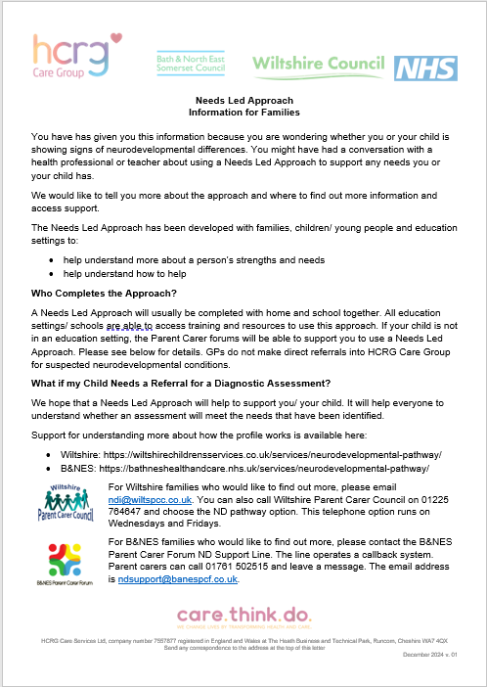
- Manual | 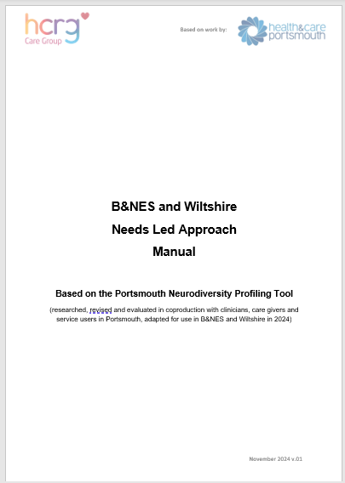
- Observation Tables for the age of the child or young person | 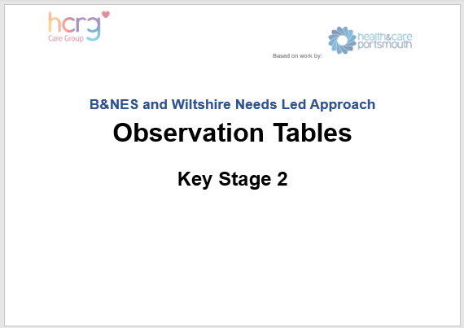
- Needs Led Profile | 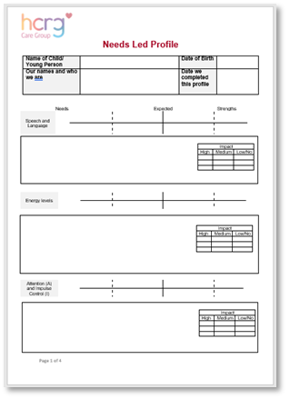

The Needs Led Approach Levels
The Needs Led Approach has three levels:

- Level 1 – Identifying and supporting needs and differences

- Level 2 – Reviewing and adjusting support

- Level 3 – Seeking advice from the ND Pathway where needs are not being met and having a significant impact

The main objective at each level is to understand needs and differences, provide advice, guidance and appropriate support. Children/young people may move through from Level 1 to Level 2 or Level 3 when needs and differences indicate a higher level of impact. They may also stay at a particular level if it is helping.

Summary
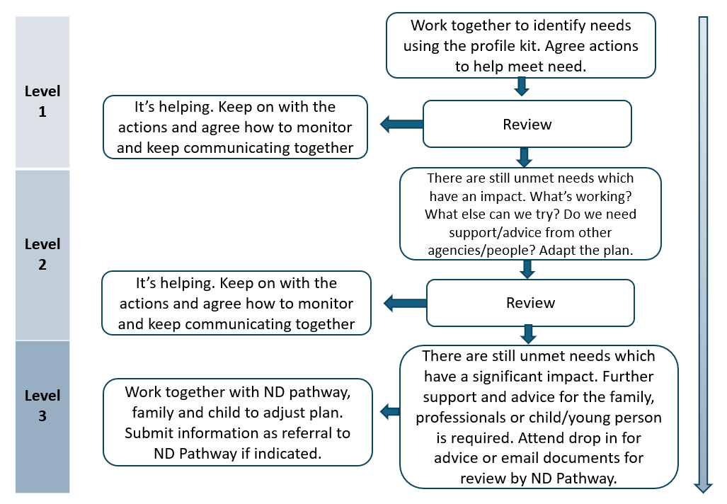

The Observation Tables
The Observation Tables contain descriptions of a range of strengths, needs/ differences and expected development for each age group. These are organised into the nine Neurodevelopmental Areas discussed in Section 1.
Select the Observation Table for the age group of the child/ young person you are profiling:
- Babies (6 -12 months)
- Toddlers (1-3 years)
- Early Years (4-5 years)
- Key Stage 1
- Key Stage 2
- Key Stage 3
- Key Stage 4/5
Parent, school and the child/young person can work together to select the descriptions that best fit the child/young person. It can be useful to highlight the descriptions using different colours for home, school, home and school and child/young person.
- Speech and Language Skills

Speech refers to saying sounds accurately and in the right places in words. Language refers to understanding and use of spoken language. Communication refers to being able to communicate with people; this can include verbal and nonverbal communication
Explanations to consider when high needs and impact are indicated:

- Hearing impairment (could be fluctuating)
- Shyness
- Speaking only in selective situations due to anxiety
- Mental health needs e.g. anxiety
- English as an additional language
- Environment- including limited early stimulation and exposure to language
- Language or speech disorders
- Attachment difficulties

- Energy Levels
Energy levels are the degree of physical activity that you notice. Energy levels can be described as being hypoactive (low energy levels) or hyperactive (high energy

levels). It is important to understand whether energy levels are high or low because it can change the support that is needed. It might be easier to notice a child/young person who is fidgeting, fiddling and constantly moving than a child/young person who seems quieter than other children and who tends to keep to themselves. Hypoactive behaviour may require support just as much as hyperactive behaviour.
Explanations to consider when high needs and impact are indicated:

- Bedtimes/ sleeping differences
- Food and nutrition
- Suspected absence seizures
- Mental health needs

- Attention and Impulse Control
Attention
Attention refers to the ability to focus on a task.
Impulse control
Impulse control refers to the ability to think before acting, being patient and being able to wait for a turn.
When impulse control is low, a person can jump to conclusions, make decisions too quickly without thinking about the consequences, be focused on here and now and not be able to think and wait for rewards in the future.
When impulse control is high, a person may be unable to make any decisions, and may need someone else (like a caregiver) to make a decision.
Explanations to consider when high needs and impact are indicated:

- Hearing impairment (could be fluctuating)
- Bedtimes/ sleeping differences
- Language needs
- Learning needs
- Sensory needs
- Environment- including opportunities for developing attention to different types of activity

- Emotional Regulation
Emotional regulation is the ability to manage and respond to an emotional experience. It is heavily correlated with many factors like sleep, diet, mental health, and stresses in life (Gruber, & Cassoff, 2014; Compare et al., 2014).
Explanations to consider when high needs and impact are indicated:

- Mental Health needs e.g. anxiety
- Bedtimes/ sleeping differences
- Environment- including changes or challenges in school and/or home life
- Toileting

- Motor Skills
Motor skills can be broken down into two distinct categories:
- Gross Motor skills require the use of large muscles in the body to complete tasks such as walking, maintaining posture or crawling. Most of these skills are developed during infancy and remain unchanged even after long periods of not being used.

- Fine Motor skills require the use of small muscles in the body to complete tasks. These are in the fingers, hands, toes and feet, and are precise in nature. Tasks that require fine motor skills include playing of an instrument, handwriting, sewing, using buttons on clothes or anything which require a high amount of dexterity. Usually, without prolonged use, fine motor skills are subjected to degradation and require ongoing practice to maintain the skills. Fine motor skills usually develop and consolidate later than gross motor skills.
Difficulties with motor skills can lead to issues in other areas such as managing emotions or the ability to concentrate and think. When there are difficulties, energy and focus may be directed on the motor task and can negatively impact someone’s ability to cope with other demands such as loud busy places or friendships.
Explanations to consider when high needs and impact are indicated:

- Confirmed diagnosis of Developmental Co-ordination Disorder DCD (previously known as dyspraxia)
- Environment- including opportunities for developing fine or gross motor skills

- Sensory Processing
Sensory Processing refers to the way a person process the input from the senses. Many people could identify these five senses:
- Sight
- Touch
- Hearing
- Smell
- Taste
We can also include these senses:
- Proprioception (position in space)
- Vestibular Function (balance)
- Body Function (sense of how the body is feeling)
Everyone processes sensory information differently; some differences have an impact on daily function.
Explanations to consider when high needs and impact are indicated:

- Pain
- Ear infection
- Tiredness
- Environment- including opportunities for experiencing different sensory input
- Flexibility and Adaptability
Flexibility is a person’s ability to think of and decide upon a range of options when no change is required. Flexibility is the internal decision-making when presented with a task.
Adaptability is a person’s ability to cope when change is required. Adaptability is the ability to alter behaviour to meet the requirements of the situation.
If a child is asked to play, being able to decide upon and talk through different options is a display of flexibility. Being told that they must play a certain game and then joining in is a display of adaptability.
People with less flexibility and adaptability may be described as rigid thinkers. They may prefer to have a set timetable and organize themselves to a set plan. Having a more rigid thinking profile can have advantages, such as a high degree of organisation and planning.

At the opposite end of this spectrum are those people who have a high ability to be flexible and adapt to their surroundings.
Explanations to consider when high needs and impact are indicated:

- Mental health needs e.g. anxiety
- Sensory needs
- Language needs
- Learning needs
- Environment- including changes or challenges in school and/or home life, the opportunity to practice adapting and flexing

- Social Interaction and Social Relationships

Social interaction refers to reciprocal interchanges between people including initiating social interaction, responding to one another and sharing enjoyment.

Social relationships refers to building and maintaining relationships including friendships with peers, behaving in an expected way in social situations and understanding different types of relationships.

Explanations to consider when high needs and impact are indicated:

- Mental Health needs e.g. anxiety
- Environment- including changes or challenges in school and/or home life
- Sensory needs
- Language needs
- Learning needs

- Cognitive Ability
Cognitive ability encompasses lots of areas. For the focus of the Needs Led Profile we are considering a number of different skills including:

- Memory
- Visual and auditory perception
- Cause and effect
- Planning, sequencing and organising
- Processing information

Explanations to consider when high needs and impact are indicated:

- Tiredness
- Nutrition
- Illness
- Mental health
- Specific Learning Difficulties

Creating the Needs Led Profile
On the Needs Led Profile, you will see nine sliders with the name of the profile area the left-hand side
Needs Expected Strengths
Speech and Language

Use the information from the Observation Tables to indicate where the child’s development is on each profile slider. You can use a cross (parent/carers), a circle (school) and a triangle (child/young person) to show the child/young person strengths, expected skills and needs. You could also use different colours.
Any marks closer to the left-hand side indicate more needs and marks on the right-hand side indicate fewer needs. Marks closer to the middle indicate expected behaviours for that child’s age and stage.
Note: In the ‘Attention and Impulse Control’ area, you can mark ‘A’ and ‘I’ to indicate the skills in these different areas of development.
Sometimes there are observations which indicate expected development, strengths and needs. We expect that most children will have a mixed profile like this. It is important to notice how much of the development has been identified in each section and make a ‘best fit’ decision e.g. if the child’s development is mostly within the expected section, with a few needs and a few strengths, then you would mark the cross around the ‘expected’ line.
i.e.
Needs Expected Strengths
Speech and Language

Underneath each slider there is a free text box to add any comments to explain where the marks have been added. This can be useful to reflect differences in particular areas which aren’t reflected by the position on the slider.

Within the free text box there is also an impact rating. Use the symbol (cross /circle /triangle) or the colour scheme to indicate the level of impact in that area for each person completing the profile. Impact is likely to be different between settings because of different environments, different strategies being used and different understanding of need.

Section 3: Using the Profile to Identify and Plan Support
What people have told us:
‘….[The parent carer advisor] gave me ideas and strategies to try at home. I’ve learned so much about how my children behave and process things throughout this whole process’
Parent carer feedback from the pilot project- October 2024
‘ ‘It was really good to see what they’re doing in school and I was pleased to have a copy [of the Action Plan] to take away as it was a lot to take in’
Parent carer feedback from the pilot project- October 2024
You will need:
- Completed Profile | 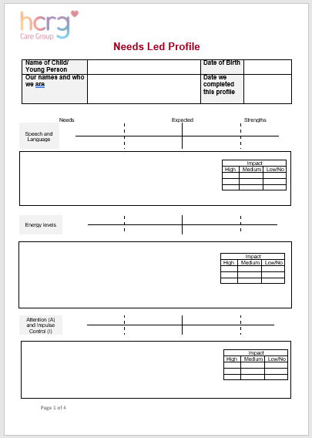
- Manual | 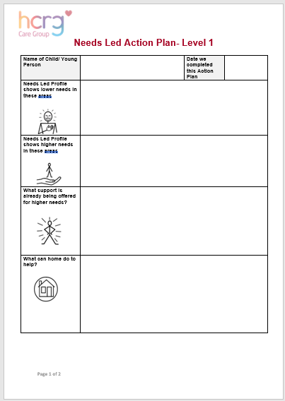
- Resources Pack | 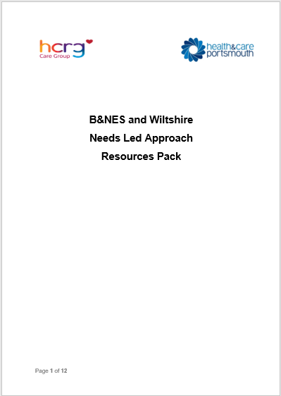

Level 1 - Creating and Reviewing Action Plan
Once the profile has been completed for the nine areas, the information can be added to the Needs Led Action Plan. Some people have found that as they have been completing the nine areas, actions can be populated straight into the action plan rather than waiting until the profile has been fully completed.

These are the boxes to be completed on the action plan:
- Needs Led Profile shows lower needs in these areas

- Need Led Profile shows higher needs in these areas

Consider what support is already being offered both at home and at school and what strategies the young person may be using.
- What support is already being offered for higher needs?

Consider what new or additional support/ understanding/ advice/ strategies can be used. Use the Needs Led Resources Manual to ensure you have considered a range of ideas for actions.
- What can home do to help?

- What can the setting/ school/ other professionals do to help?

If appropriate, please discuss the profile and action plan with the young person and add
- Young person’s comments about the action plan
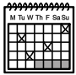
Make a date to review the action plan. We usually recommend six weeks, but this could be longer depending on the actions you’ve identified.
- Date we will review this plan
We anticipate that Level 1 will provide the support to meet the needs of most children/young people who have needs/ differences in the nine neurodevelopmental areas.
If there are a lot of actions that have come from reviewing the profile then choose two or three to put in the Action Plan. Choose ones to support the needs that are having the most impact and keep a note of the other action ideas as these could be considered at Level 2 if required.

Level 1 Summary
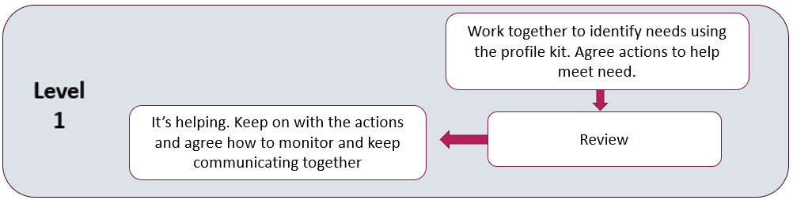
After six weeks (or longer depending on the actions), the Action Plan- Level 1 can be reviewed with home, school and young person if appropriate.
If needs are being met, keep going with the actions and agree how to monitor and keep communicating with each other.
Needs Led Review- Level 1/ Action Plan- Level 2
In some cases, when you review the Action Plan using the Level 1 review paperwork, there may still be unmet needs which are having an impact. The Action Plan may need to be adjusted to meet these needs. This is Level 2.
There will be a number of possible next steps for children at Level 2. These steps will look different for each child and may include accessing advice from a range of services about how to best meet the needs identified on the profile. Please refer to the Needs Led Approach Resources Pack for additional advice and support and complete the Action Plan-Level 2.
We anticipate that Level 2 will provide further support and understanding to meet the needs of most children/young people.
Level 2 Summary
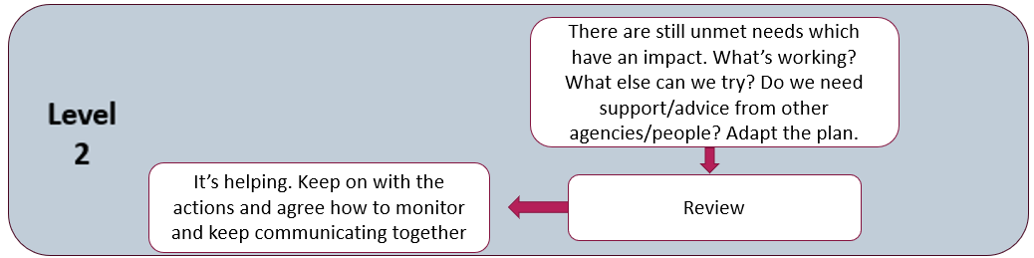
After six weeks (or longer depending on the actions), the Action Plan- Level 2 can be reviewed with home, school and young person if appropriate.

If needs are being met, keep going with the actions and agree how to monitor and keep communicating with each other.
Needs Led Review- Level 2/ Action Plan- Level 3
In some cases, when you review the Action Plan using the Level 2 review paperwork, there may still be unmet needs which are having a significant impact. The Action Plan may need to be adjusted to meet these needs. This is Level 3.
Further support and advice may be required. The ND Pathway run weekly drop-ins on Microsoft Teams which provide an opportunity to discuss ideas for support or next steps. You can email us (see contact section) to request links to these sessions.
If you have completed Level 3 and think that the ongoing needs are significant and could be supported by diagnostic assessment, you will need to share the Level 3 paperwork with the ND Pathway via a secure link. Please contact the Single Point of Access to arrange this. You will need to include:
- Observation Tables
- Profile
- Action Plans
- Information to help us understand why the young person/ and the family feel that a diagnostic pathway is a suitable next step to meet ongoing needs
The ND Pathway will review this information. We will provide information and advice about additional adjustments or support to put into place. We may also identify that a referral to the ND Pathway for diagnostic assessment is indicated and advise you how to submit a referral if this is the case.
Level 3 Summary
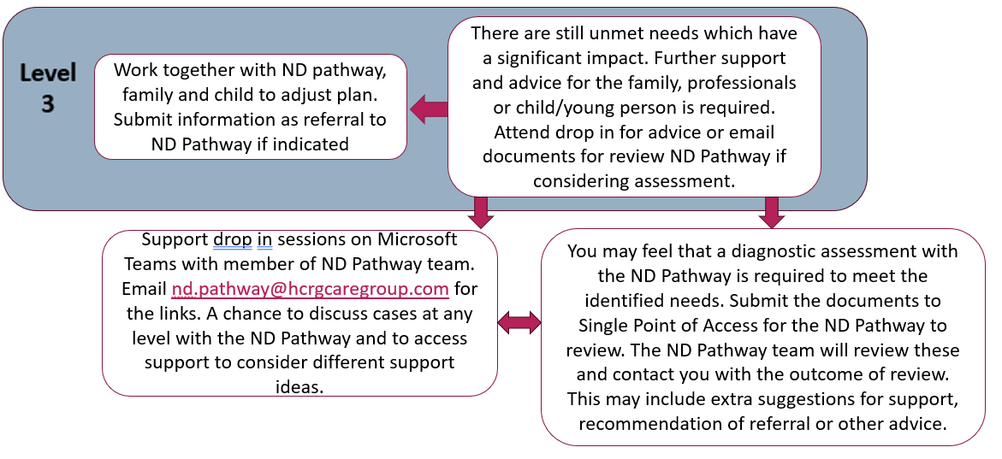

What if Referral for ND Assessment is Recommended by the ND Pathway?
If ND assessment is recommended at Level 3:
It is important to help the young person (and family) understand that
- The child would still be the same person
- The child and parents must consent to considering an ND assessment
- If a diagnosis is given, this is lifelong and will not be removed unless there is significant information which suggests it is not appropriate
- A diagnosis of autism/ ADHD does not automatically provide additional support in school such as an Education, Health and Care Plan (EHCP). An EHCP is a needs-based support plan.
- Some career paths and visa applications may ask for any diagnosed conditions to be disclosed
- Once referred, a Needs Led Approach to support must continue
Many parents and young people have told us that they seek a diagnosis in order to access support and understanding. For many, this can be accessed via the Needs Led Approach and does not require an ND assessment pathway.

Section 4: Essential Information

Frequently Asked Questions
Working with Parents/Carers
We are worried that the Needs Led Approach may lead to parent carers requesting actions that are unrealistic for our school.
One of the key principles for action planning is that the actions are realistic. No one is helped by setting unrealistic actions! This applies to parents as well as schools and is another reason why it is so important to work together to understand each other.
How do I start the conversation with parents?
Some settings have found that sharing the manual and talking through the observation tables are a good place to start. We hope the ‘Information for Families’ letter will provide some additional support for families and enable them to understand more about the Needs Led Approach at their own pace.
How do I capture different views when parents are separated?
It is important that all views are included in a Needs Led Approach. It is OK to have different opinions if you can’t agree. These can be marked differently on the sliders to show who thinks what.

What support is there for parents who are considering the Needs Led Approach?

The key support is detailed in the ‘Information for Families’ letter which you need to share with parents when you are considering this approach. This contains information about The B&NES Parent Carer Forum ND Support Line and Wiltshire Parent Carer Council (WPCC) ND advice line
Can I share the Manual, Observation Tables and Resources Pack with parents?
Some parents have told us that this can be rather overwhelming and it can also lead to parents and school working in silo, rather than collaboratively. We recommend having a conversation first, then providing parents with the ‘Information for Families’ letter.


The Profile Kit
Where can I find the documents I need for the Profile?
All the documents are available on our website
Who can complete a Needs Led Approach Profile and Action Plan?
Anyone who has completed this training session can complete the Needs Led Approach work, as long as this is a collaboration between all those working with the child and the family.
What people have told us:
‘I have completed a staff meeting for all staff to talk about the profile and action plan as a starting point’ (Feedback from Primary SENCO, pilot project May 2024)
‘I have arranged a meeting arrange to discuss with the Head Teacher, then will feedback to staff at a meeting and ask them to identify children that the profile can be considered for’ (Feedback from Primary SENCO, pilot project May 2024)

Access to Support
How does this fit with other support documents e.g. EHCP or ESA?
A Needs Led Approach Profile and Action Plan is useful for identifying more specific areas of need at any particular time. If a child has another support plan in place, it is a good idea to reference this as part of the Action Plan. Although lots of work goes into plans, we have found that sometimes parents and carers aren’t sure what is happening and can feel that they don’t know what to do to help. A Needs Led Action Plan can reassure parent carers about what is happening in school and help provide support and advice for what home can do to help.
If there are wider support needs in the family, it might not be the right time to also consider a Needs Led Approach plan.
What people have told us:
‘We have found it more parent/school friendly than an IEP. It’s more accessible and parents are more part of it’ (Feedback from Primary SENCO, pilot project May 2024)

Does a child need a diagnosis for support to be in place at school or an Education, Health and Care Needs Assessment (EHCNA)?
Support in school is needs led, rather than diagnosis led.
I think a child in my school needs a diagnosis to meet a very specific need. How do I find out more?
Please contact the ND Pathway to discuss if you think that lack of diagnosis is impacting on your ability to meet a child’s needs.

Assessment with the ND Pathway
If the Needs Led Approach indicates that a referral to the ND Pathway is required, do we stop the Plan-Do-Review cycles?
No, the support is still required for a child and family, whether they are on an assessment pathway or not. The support is related to needs, not related to a diagnosis. Not all children with a diagnosis will require a Needs Led Support Approach because their needs may be well understood and supported by those around them already.
Can I complete a Needs Led Approach Profile for a child who already has a diagnosis or is on the Assessment Pathway?
Yes! Trying to understand needs and offer support for each child regardless of diagnosis is the aim of the approach.
I don’t have enough time to complete a profile for all the children in my school who need a referral. What shall I do?
Think carefully about why a referral is needed. What are the needs of the child or family? Can these be met without a referral? Think about other members of the team who may be able to develop skills in the Needs Led Approach. This training is available for all.
Do GPs know about this approach?
Yes. GPs have been told about this via the ICB newsletter and GP briefing sessions.
What people have told us:
‘Often there is a bit of a lightbulb moment that ND pupils aren’t going to magically be different by going through this process or getting a formal diagnosis. Sometimes that can be hard…but I feel that just by sharing struggles and acknowledging that it is the world that has to change not just the individual is helpful.’ (Feedback from Primary SENCO)

Contact Details

- ND Pathway Website:
Provides information about the Needs Led Approach including the training webinar and all the documents required.
B&NES: bathneshealthandcare.nhs.uk/neurodevelopmental-pathway/
Wiltshire: wiltshirechildrensservices.co.uk/neurodevelopmental-pathway/
- ND Pathway Email Address:
For requesting links for Professionals’ drop-in sessions to discuss general support about using the Needs Led Approach. (The drop-ins are not for discussion of named cases due to confidentiality considerations). If you are unable to attend the planned drop- in sessions, please let us know when you are able to discuss your query with you.
nd.pathway@hcrgcaregroup.com
- HCRG Care Group B&NES Single Point of Access
Tel: 0300 247 0055 . Office hours are 9 am to 4.30 pm
Email: hcrg.bathnesspa@nhs.net
- HCRG Care Group Wiltshire Single Point of Access
Tel: 0300 247 0090. Office hours are 9 am to 5 pm.
Email: vcl.wiltshirespa@nhs.net
- B&NES Parent Carer Forum
The B&NES Parent Carer Forum ND Support Line helps parent carers understand the Needs Led Approach in Bath and North East Somerset and provides support and advice about this. The line operates a callback system. Parent carers can call 01761 502515 and leave a message. The email address is ndsupport@banespcf.co.uk.
- Wiltshire Parent Carer Council
Wiltshire Parent Carer Council (WPCC) ND advice line is open Wednesdays and Fridays 10am – 5pm. Parent/carers can all the WPCC on 01225 764647 and select option 2. If there is no reply, they can leave a message and they will be called back. They can also send an email to: ndi@wiltspcc.co.uk.

